04-08-2026 CSA0927-PROGRAMMING IN JAVA SRITHIKA.K
192524449

1. 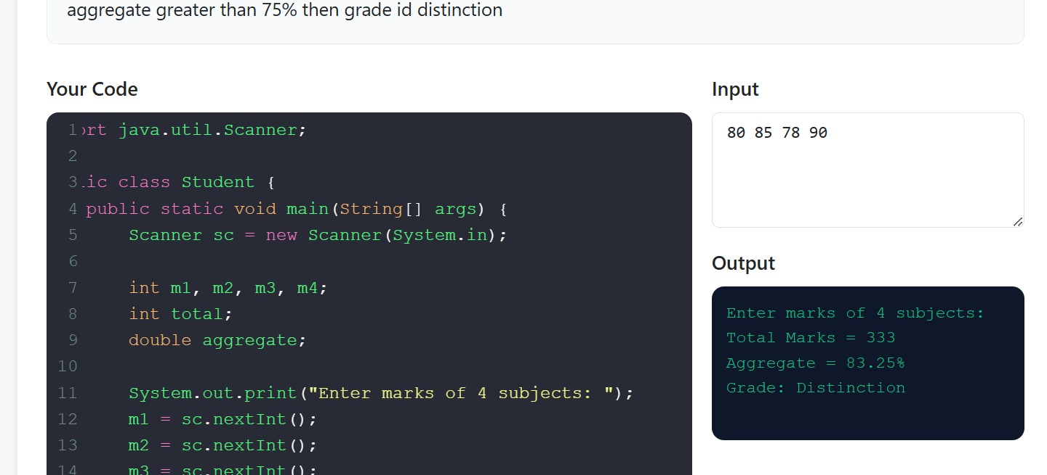

2. 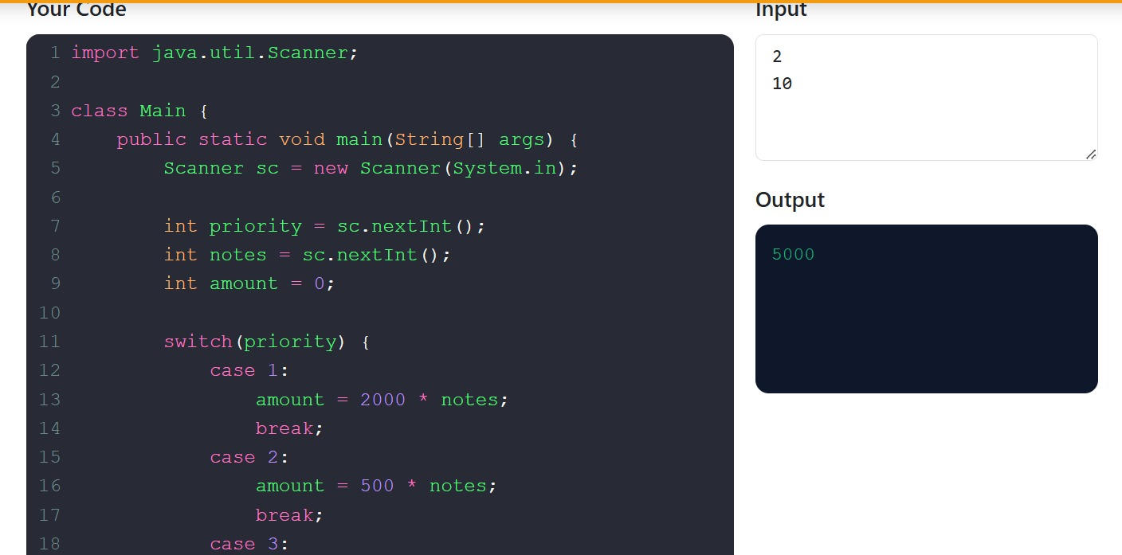

3. 